Digital Pre Distortion

Power amplifiers (PAs), which are inherently nonlinear systems, are essential components in a communication systems. The nonlinearity causes in-band distortion and a spectral regrowth, which leads to interference and violations of the out-of-band emission requirements. The use of different transmission formats, such as wideband Code Division Multiple Access (CDMA) or Orthogonal Frequency Division Multiplexing (OFDM), which are known to have high peak to average power ratios, increases the risk of using voltages that are close to the PAs saturation point, as this will lead to a severe distortion, as mentioned above. For this reason, PA linearization methods have gained popularity and increasing interest in recent years.

Digital Pre Distortion (DPD) is one of the most effective techniques of PA linearization. In this technique, a digital non-linear block, known as a Predistorter, is used in front of the Analog to Digital (A/D) component,  The role of the Predistorter is to distort the signal in a way that will be, in turn, compensated by the PA. Ideally, the total response of the Predistorter and PAs will be linear up to some saturation voltage.

The  PA nonlinearity may be characterized in many ways. In this work, we will concentrate on three types of distortion of the output signal: in its  amplitude (also referred to as Amplitude Modulation/ Amplitude Modulation (AM/AM) distortion), phase (also referred to as Amplitude Modulation/ Phase Modulation (AM/PM)) and bandwidth.

AM/AM is the relation between the amplitude of the input signal and the amplitude of the output signal, which ideally should be linear, but due to non-linear components in the PAis usually nonlinear. AM/PM is the relation between the amplitude of the input signal and the phase difference between the input signal and the output signal. Ideally, the phase difference should be zero.

PAs also exhibit memory effects. This means that , the current output of the PA depends not only on the current input, but also on past input values, and makes the power amplifier a nonlinear system with memory. Therefore, digital predistorter should also have memory structures.

An example of a schematic description of a DPD system is given in רפרנס

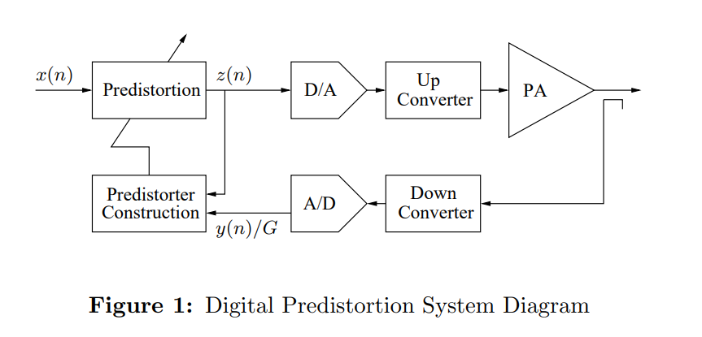

“Digital Predistortion of Power Amplifiers for Wireless Applications “, Lei Ding

AM/AM and AM/PM

AM/AM and AM/PM distortions in power amplifiers are distortions occurring when the PA system is nonlinear. Due to its nonlinearity, it can create harmonics of the fundamental frequency of the input signal. For example, if a signal which has two fundamental frequencies, $f_{1},f_{2}$, is entered into a nonlinear PA, output signal will contain new frequency components, which will be in the form of $nf_{1}±mf_{2}$, when n and m are integers. Out-of-band frequencies can be ignored by filters, however, in-band frequencies cannot.

AM/AM distortion is when output amplitude is not a linear function of input signal amplitude. It usually happens in the higher range of input signal amplitudes. This nonlinearity, has been accepted in our lab’s PA, and illustrated in figure-2, where the output amplitude is shown vs input signal amplitude.

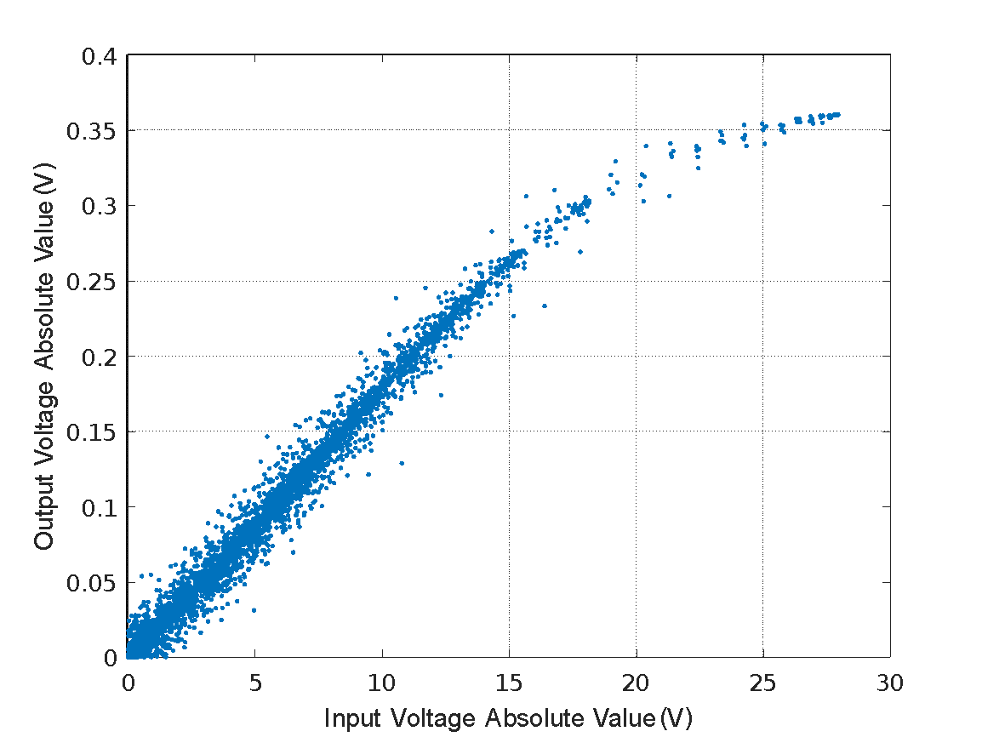

Figure 2 – illustration of AM/AM distortion caused by our lab’s nonlinear PA

AM/PM distortion is when the phase difference between output and input signal depends on input signal amplitude, and is not constant. It usually happens in the lower range of input signal amplitudes. This distortion, has been accepted in our lab’s PA, and illustrated in figure-3, where the phase difference between input and output is shown vs input signal amplitude.

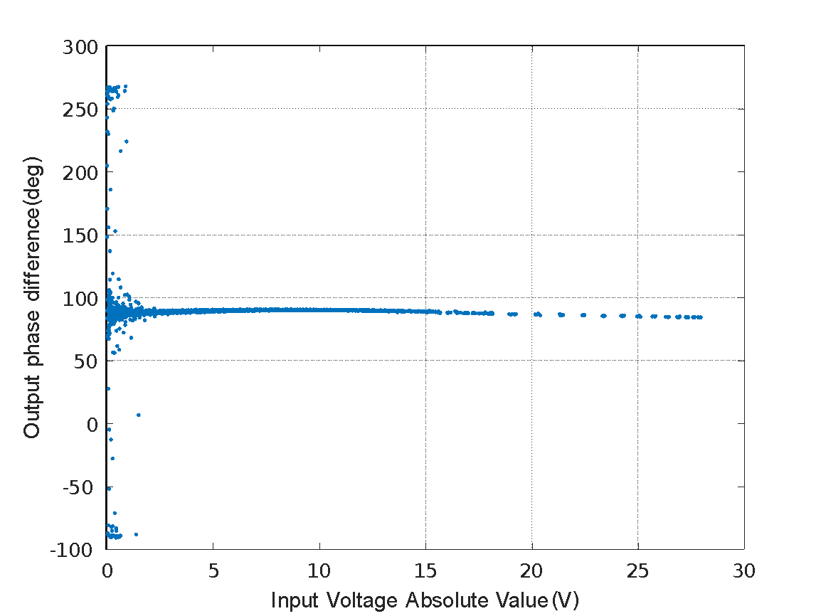

Figure 3 – illustration of AM/PM distortion caused by our lab’s nonlinear PA

Modeling power amplifier using Volterra series

Volterra series are used in order to model  systems that are both nonlinear and have memory. As such, the Volterra series are often chosen to represent PAs response צריך רפרנסים. The general form of the discrete Volterra series is given by:

$$y\left(n\right)= \sum_{k=1}^{K}{\sum_{m_{1}}^{M-1}{…}\sum_{m_{k}}^{M-1}{h_{k}(m_{1},…,m_{k})\prod_{l=1}^{k}{x(n-m_{l})}}}$$

where $y(n)$ is the output sample, $x(n)$ is the input sample, K is the order of non-linearity of the system, M is the order of memory of the system, and $h_{k}(m_{1},…,m_{k})$ is a coefficient with set values as a function of k and $m_{1}…m_{k}$

The extensive number of coefficients related with every combination of input sample and delayed input sample combinations within the bounds specified makes it possible to model large scale of nonlinear systems with memory effects. It is able to model systems with both large non-linearities and drastic memory effects, and by raising the nonlinear and memory orders, K and M, the model can become more accurate. However, the complexity in calculating the coefficients increases dramatically as either K or M is increased. As a result, many simplifications of the full Volterra model, with less coefficients, have been devised. One of these is the Memory Polynomial model, which is given by:

$$y_{MP}\left(n\right)= \sum_{k=0}^{K-1}{\sum_{m=0}^{M-1}{h_{km}x\left(n-m\right){\left|x\left(n-m\right)\right|}^{k}}}$$

where $y_{MP}(n)$ is the output sample, $x(n)$ is the input sample, K is the order of non-linearity of the system, M is the order of memory of the system, and $h_{KM}$ is a coefficient with set values as a function of 𝑘 and 𝑚. This model can be represented efficiently in matrix form as:

$$y=Xθ_{MP}$$

$$\left[\begin{matrix}y(n) \\ ⋮ \\ y(n+N)\end{matrix}\right]=\left[\begin{matrix}x(n) & ⋯ & x\left(n-m\right){\left|x\left(n-m\right)\right|}^{k} \\ ⋮ & ⋱ & ⋮ \\ x(n+N) & ⋯ & x\left(n+N-m\right){\left|x\left(n+N-m\right)\right|}^{k}\end{matrix}\right]\left[\begin{matrix}h_{00} \\ ⋮ \\ h_{km}\end{matrix}\right]$$

where 𝒚 is the outputs array of the MP model, $θ_{MP}$ is the coefficients array , and 𝑿 is an matrix containing the signal, delayed values of the signal, and their powers, which required for calculating the output. This means that the matrix can be created given only the input sample array and the order of non-linearity and memory order of the MP model to be used. The coefficient array $θ_{MP}$ contains the unknown coefficients $h_{km}$ that represents the power amplifier. In order to estimate this coefficients, one requires to have measurements of the output of the PA excited by a well known input signal. The input signal should be chosen, such that it ranges over the whole bandwidth and input amplitudes that the modeled amplifier should handle. חסר הסבר על האופן שבו נבחר האות על ידי דרור

In addition to this pair of data, one has to choose the order of non-linearity of the PA (k) and the order of memory for the MP model (m). The coefficients vector $θ_{MP}$ can be found using the well known method of minimizing the least squares error between the calculated output and measured output. The coefficients vector is given by:

$$θ_{MP}={\left(X^{H}X\right)}^{-1}Xy$$

where 𝒚 is the measured output signal, 𝑿 is the matrix detailed above, which formed by the input signal and the superscript ${()}^{H}$ is the conjugate transpose operator. In order to find the optimal coefficients for the MP model, it is essential to choose values of m and k which model PA optimally. In order to do that, one should find values of m and k that minimize the error between calculated output generated by coefficients calculated with those specific m and k, and measured output. This optimization was doen for our lab’s PA, and results are shown on figure 4. The error is minimized at k=9, m=2.

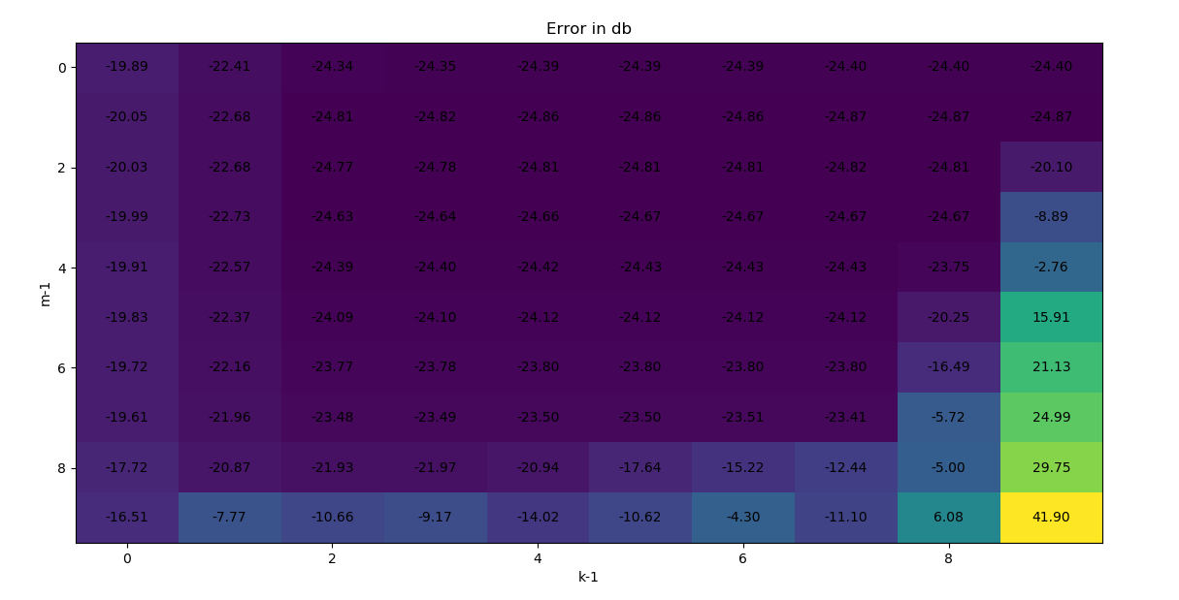

Figure 4 – error between calculated and measured output in db as function of parameters m,k

After an adequate order of non-linearity and order of memory were selected, and if the range of input amplitudes and frequencies present in a general input signal fall within those represented by the calibration data input signal, then the realistic output of the HPA can be simulated (according to MP model).

In order to check calculated parameters accuracy, several sanity checks should be made. The first one is to show AM/AM and AM/PM graphs of the calculated output and to check if they are similar to the same graphs of the measured optput. This graphs are shown in figures 5 and 6.

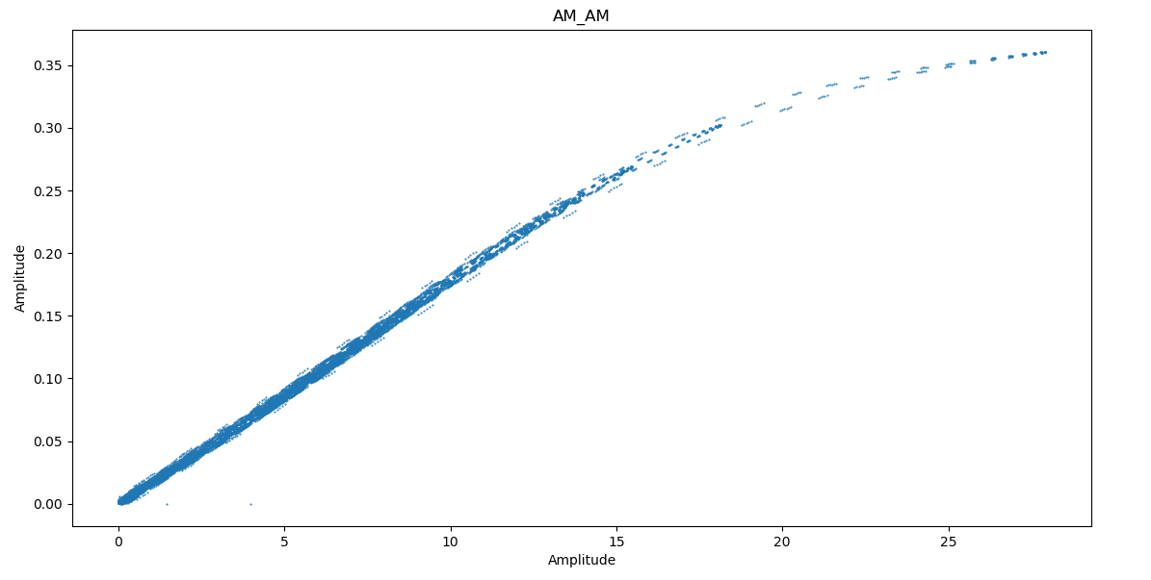

figure 5 - illustration of AM/AM distortion of input signal, caused by modeled PA

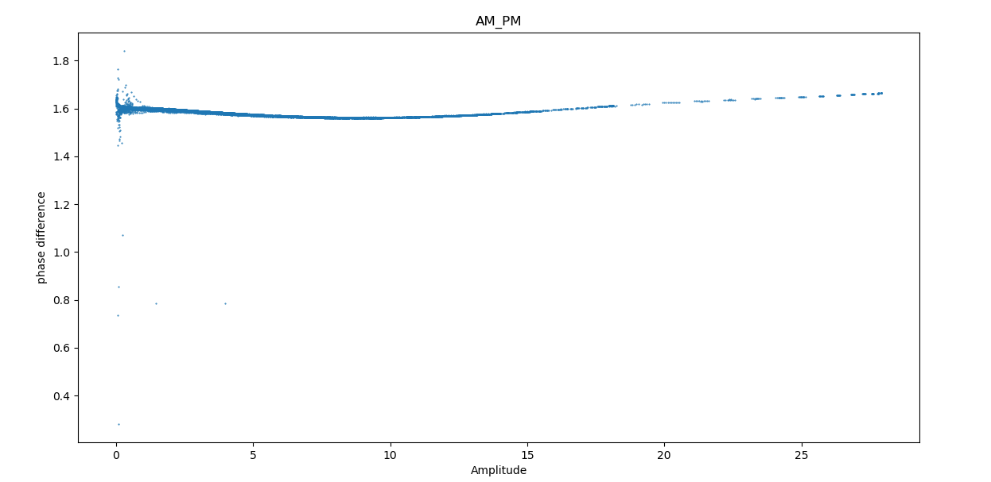

figure 6 - illustration of AM/PM distortion of input signal, caused by modeled PA

Although the above problem has an analytic solution, I used two more different methods in order to solve it for a sanity check – SGD and a proposed neural network from the article.

The first method was SGD. I set the step size $μ$ using the following formula:

$$μ=α⋅{\left(X^{H}X+ϵ\right)}^{-1}$$

While $ϵ$ was a very small number, and alpha was the regular step size. Because of that, step size $μ$ is a matrix. I did it because the gradient has radical differences between its components, and in order to handle this with SGD, the above definition for step size is required.

After I got the parameter vector $θ_{SGD}$, I made a comparison to it with $θ_{LS}$, by calculating:

$$\frac{\left|θ_{SGD}-θ_{LS}\right|}{|θ_{LS}|}$$

and the result was $0.000111≈ -80dB$

The second method for modeling was a neural network. Due to their strong adaptive nature and approximation capability, NNs are very attractive for the behavioral modeling of PAs. Several architectures for NNs were introduced in the literature. According to the article, the proposed NN, which called “augmented real-valued time delay NN” (ARVTDNN) presents reasonable performance in the presence of various distortions.